**INFO 6205**

**Program Structures & Algorithms**

**Summer Full 2018**

**Assignment 2**

A union-find is a special case from graph theory which is used to determine whether particular nodes are connected or not.

In this assignment, the union find client takes an integer value n to determine number of sites and generates number of random pairs until all sites are connected to each other.

1. **CONCLUSION:**

Some useful abbreviations:

* N – Number of sites
* PairCount – No of pairs generated to connect all sites.
* NoOfCount – No of connections which is usually N-1.

I ran the experiment for various values of N like 10,100,1000. While doing the experiment the random pairs that were generated to connect all sites were more than no of connections.

In order to prove the hypothesis:

According to the equation :

PairCount ~ ½*n*ln(n)

Lets take an example:

Value of N taken: **1000**

Program gives PairCount : 3660

½*n*ln(n)

=1/2*1000*ln(1000)

=500 *6.90775527898

~3453.87763

1. Graph of various N is given below:

Please find the table and the required files of the values below:

|  |  |  |
| --- | --- | --- |
| Value of N | PairCounts | Value acc to Hypothesis  ½ * N * ln(N) |
| 10 | 14 | 11.5 |
| 100 | 216 | 230.258509299 |
| 1000 | 3660 | 3453.87763949 |
| 2000 | 7672 | 7600.90245954 |
| 5000 | 23746 | 21292.9829785 |

For N=10 :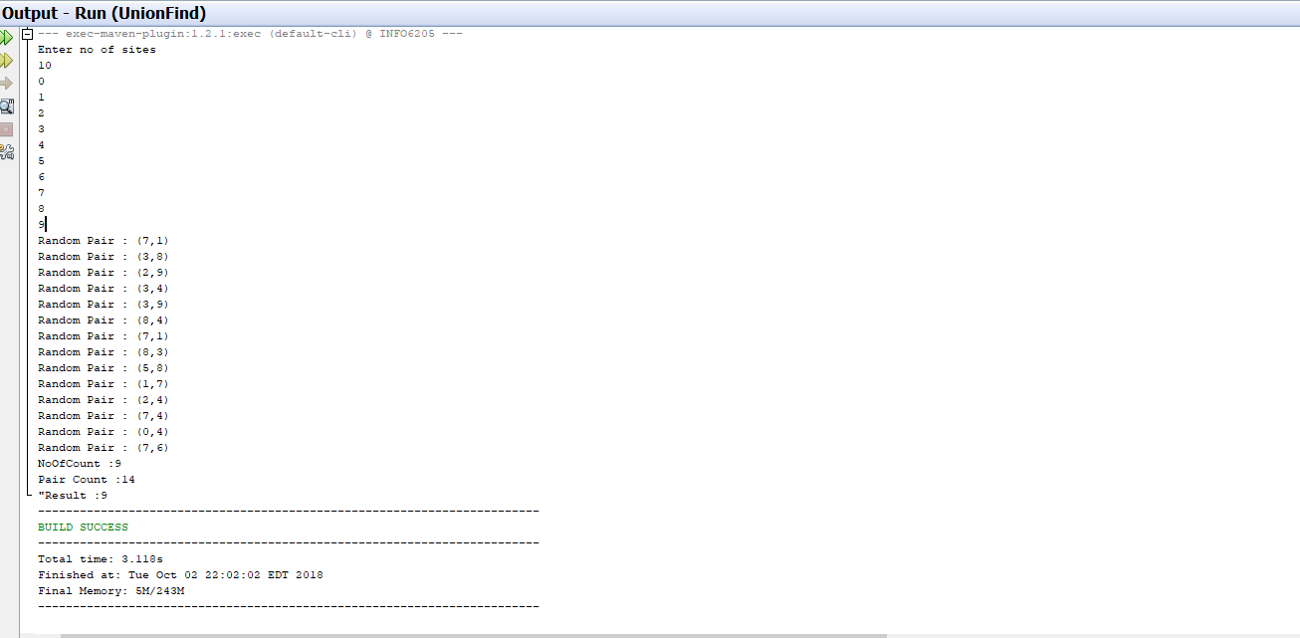

**For N=1000:**

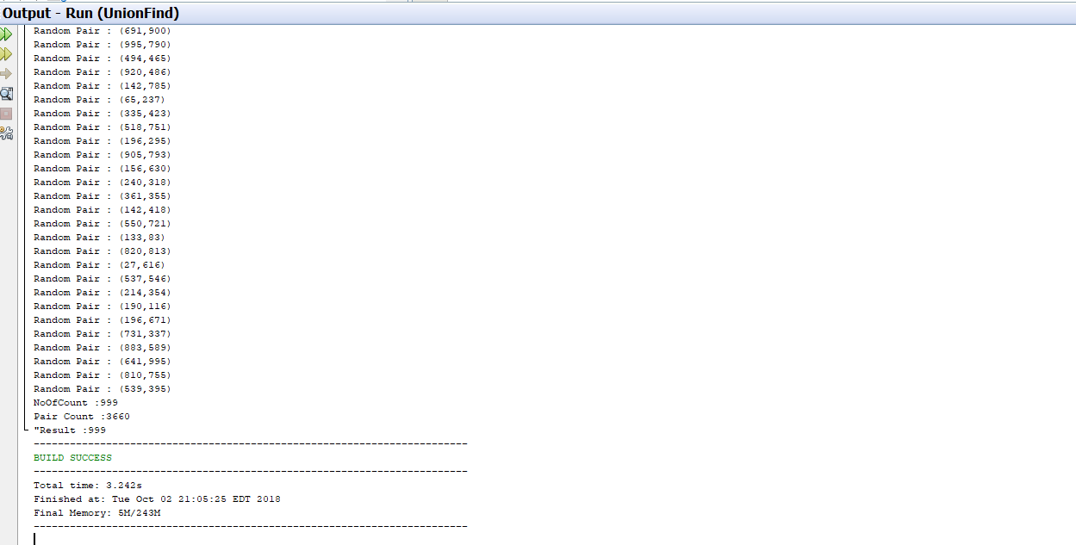

Attached files for values like 1000,2000,5000



**Hence Proved**